The Postcolonial Archive: A Roundtable
4-6pm, May 11th.
Room 4433, The Graduate Center, CUNY.

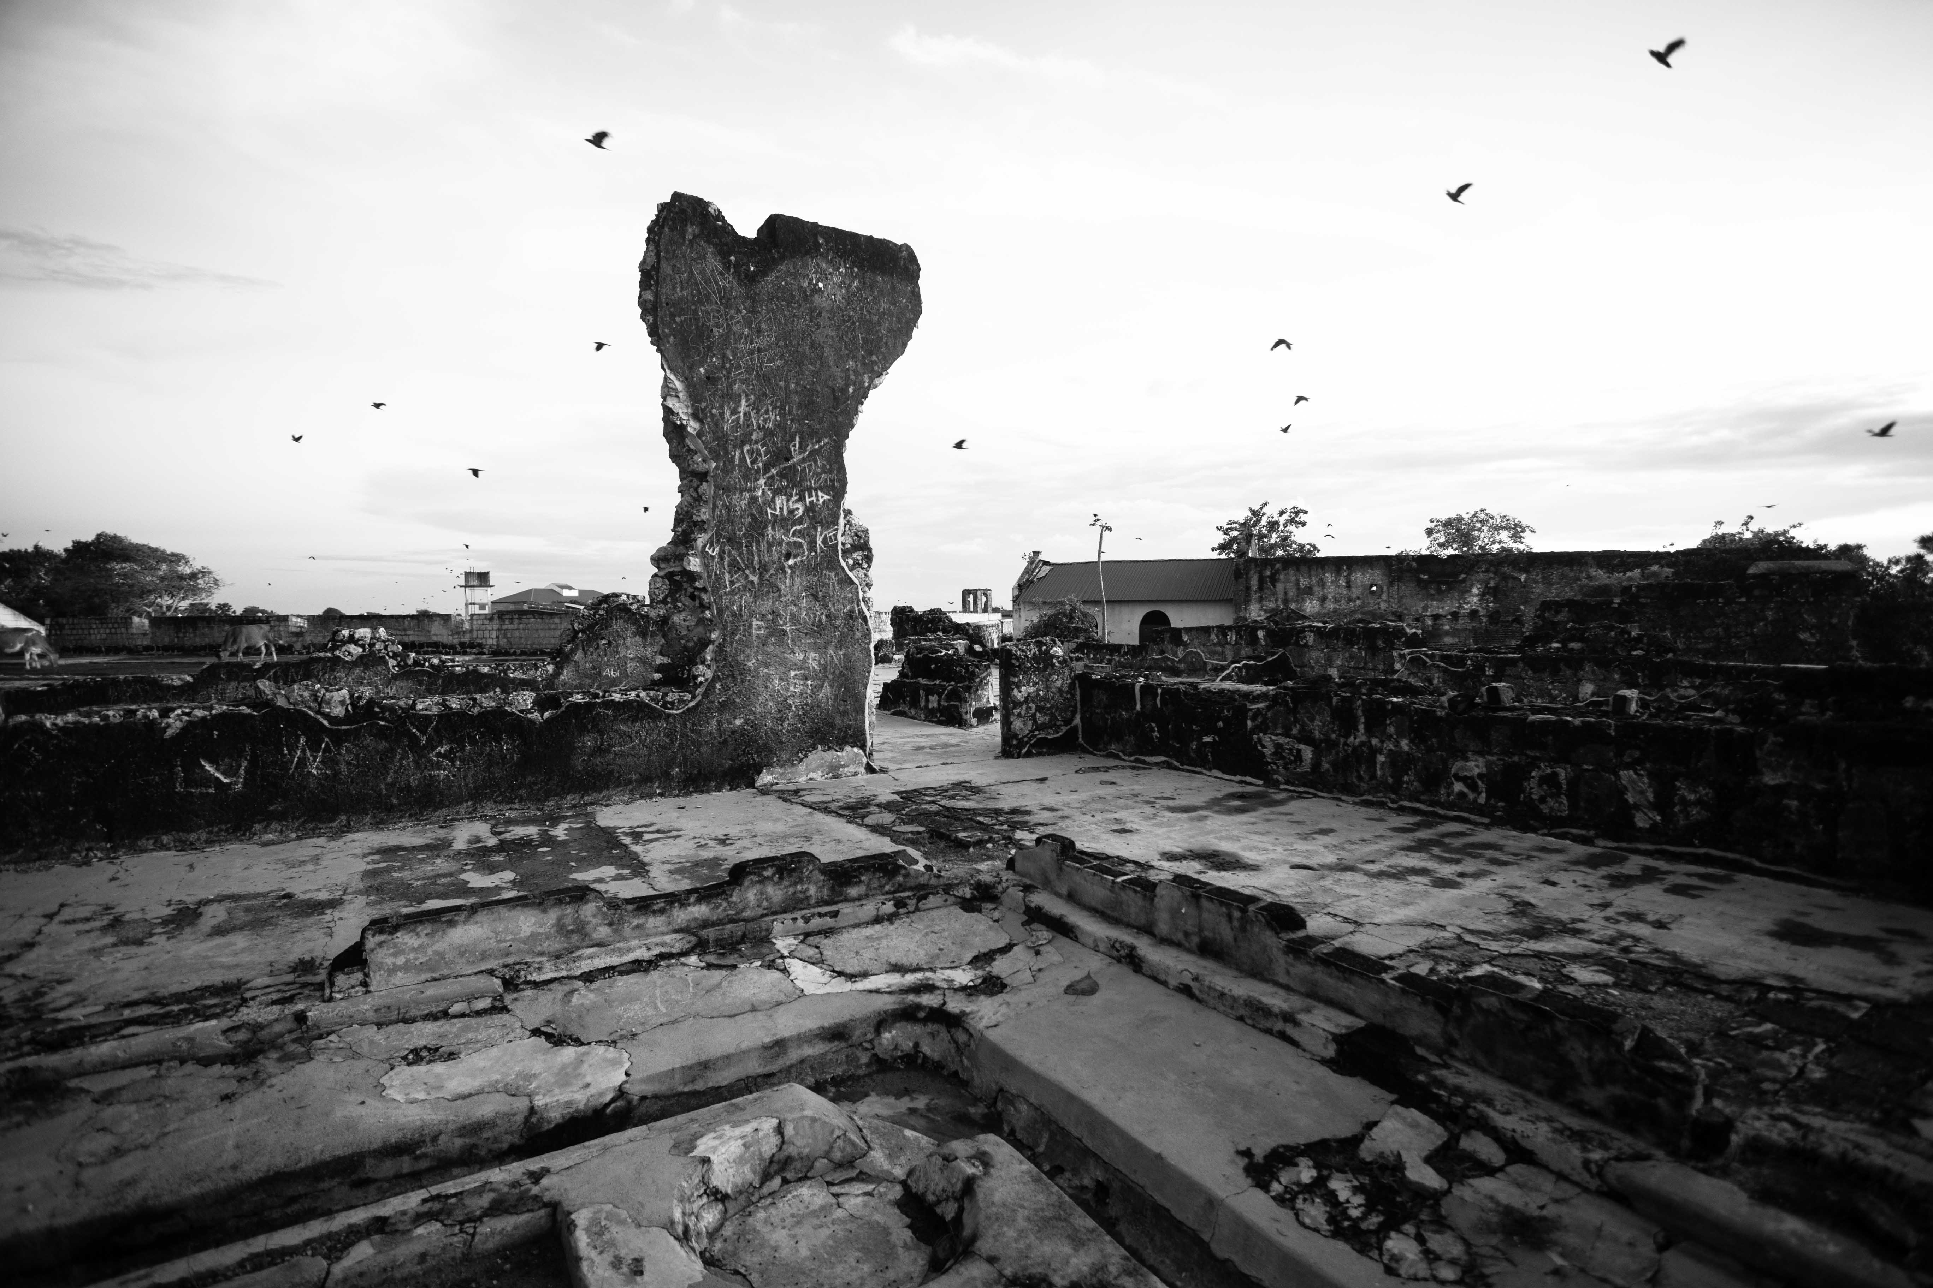

Photo Credit: Daniel Valentin

Chair: Prof. Meena Alexander (Hunter/The Graduate Center, CUNY)

An Archive within an Archive: Sri Lankan National Memory and its Exclusions:
Nadia Augustyniak, PhD Program in Anthropology
*
Mahasweta Devi: Bureaucracy and the Archive of Misery
Shoumik Bhattacharya, PhD Program in English.
*
43.Ayotzinapa, Forced Disappearances. A Cartonera Archive between Mexico and the U.S.
Elena Chavez-Goycochea, PhD Program in Hispanic and Luso-Brazilian Languages and Literatures
*
Cracked Heirlooms: How We Read Archives of Fragmentation and Healing
Maxine Krenzel, PhD Program in English.

